Active Schools Planner (ASP)
Registering on the ASP
- Click on Sign In
- Fill out mandatory fields
- Click on School Based User
Please note that the first person from a school who registers becomes the admin person for that school; they can add staff from the school to the site – see below under school users for information as to how to do this.
Please send an email to change4lifesportsclubs@youthsportstrust.org if you need any support with logging in or registering your school.
Homepage
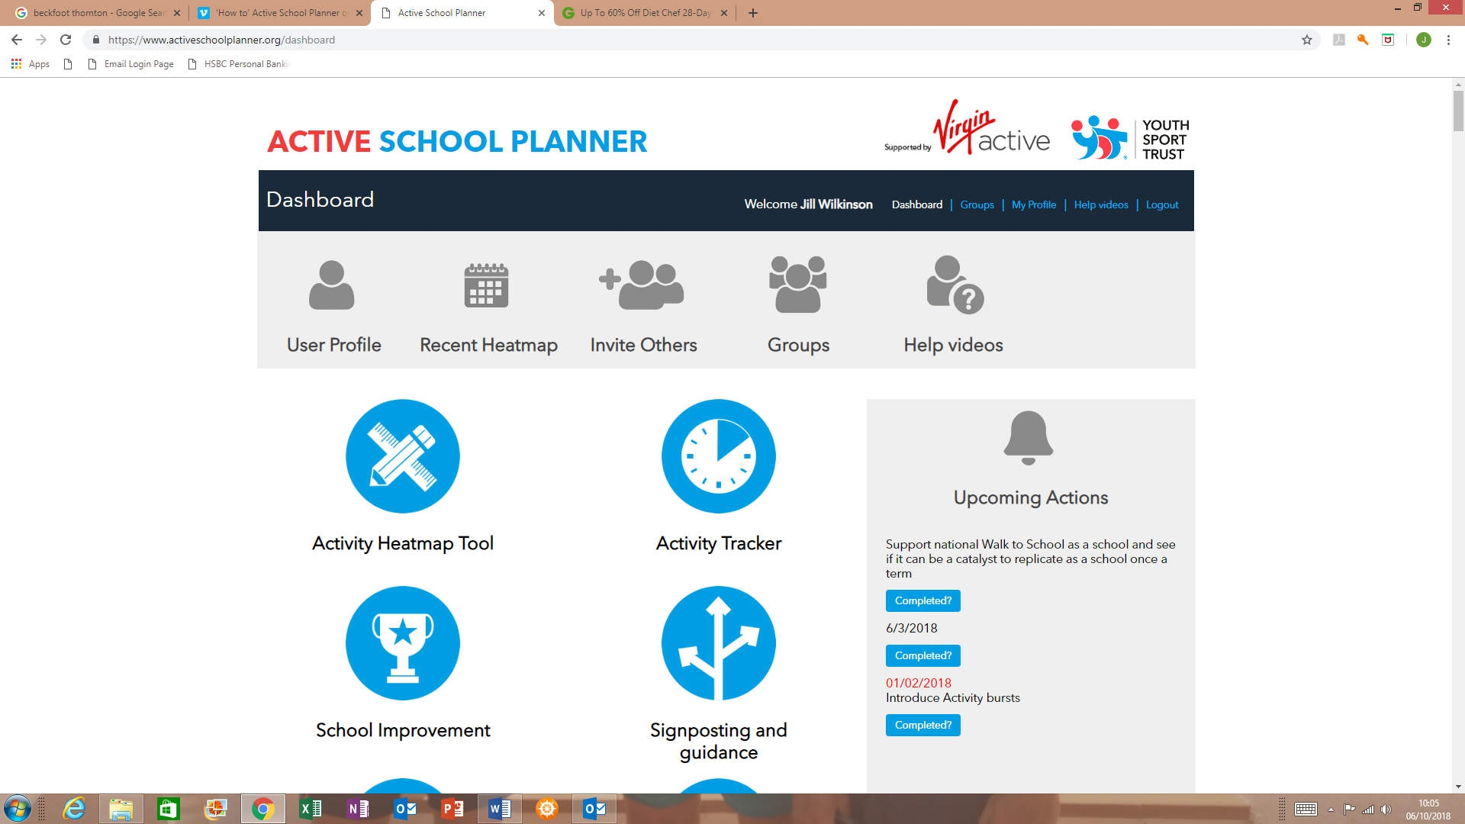
Tools (grey Icons)
- User Profile – allows account details to be updated.
- Recent Heatmap – links through to the last heatmap worked on.
- Invite Others – comments and links can be made on this page and then the system generates an email and sends it to the email accounts that have been entered.
- Groups – allows schools to segment pupil population so can refine planning and target groups etc. Schools can edit or add their own group.
- School Users – how you add users for your school. Click on Add User and choose whether you want new member of staff to have admin rights or add them as a teacher. Complete the fields on the page and then an automatic email is sent to the added new user asking them to set their own password.
Remember admin rights allow staff to see everything on the ASP that has been developed for that school, i.e. any heat maps or action plans, a teacher will only see what they have inputted on the site.
- Help Videos – videos which explain the site and help people to use it effectively, most videos are 1.5 – 3 minutes long.
Key Features (blue icons) - Hover over blue icons and it explains what each feature is, there are also some help videos if you click on the Help Videos icon.
- Activity Tracker – through this icon, schools can access the Sport England Active Lives Children and Young People Survey - if schools want to take part in this they can choose to do so, and it does support schools in identifying the least active pupils in the school so that some targeted wok can be completed.
- School Improvement – this provides the evidence which shows the link between physical activity and achievement outcomes. There are a series of infographics which can be flicked through by using the arrow icon at the bottom of the page. Under some infographics, there is a link icon – this takes you through to any national infographic which has been developed to support the information.
- Signposting and Guidance – this demonstrates the Public Health England resource which looks at the evidence around what works to promote physical activity in schools.
- Physical Activity Library – if you have shared a heatmap or uploaded file, it will display here, as will documents and heatmaps shared by other schools / organisations.
- Activity Heatmap Tool – this is a key feature of the website and supports schools to self-evaluate current activity levels. When you click on the icon, it will bring you to the last heat map that you worked on. Please see below, Creating Heatmaps, for more detail about the heatmap function.
Upcoming Actions – this appears on the right-hand side of the dashboard and listed underneath the heading are any upcoming actions for the school.
If you scroll down to the bottom of the dashboard page, there are tweets / social media clips- this allows schools to share good practice. Use #YSTActiveSchool so that your tweets appear on this page.

Creating Heatmaps
Click on the Activity Heatmap Tool icon
To create a new heatmap: -
- Click on Add Heatmap
- Set a few parameters (name of heatmap, heatmap group) – it is important to name the heatmap at this stage, so you recognise it for use at a later date
- Click on Share uploaded files publicly with other schools if you want to share the heatmaps with others
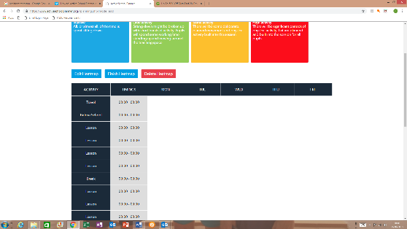
- Click Save and this will take you through to the blank template

- Firstly, look at the black column and make this relevant for your school. A red cross will appear when you hover over the titles in the black column, such as lesson, break. Click on the black cross to delete any rows. There is also an add function at the bottom of the black column
- Click on the titles in the black column and this will open a window to allow you to fill in times and complete the details for that section of the school day
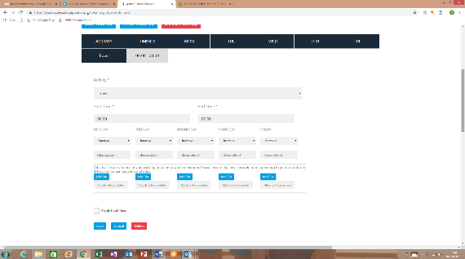

- By filling in the description, you can add any details, i.e. Active Literacy or the number of children who walk to school at that time; these details will then appear on your heat map in that section
- If you want to use the heatmap as evidence for Ofsted or PE and Sports Premium, you can
- Click on Add File, this will allow you to upload any documents to the heat map.
- Click on I accept the terms and conditions icon
- Click Save - an icon will appear on the relevant section of your heatmap showing you have a file uploaded as evidence for that section

- Always click on Finish Heatmap – this will automatically take you onto the action planning page
- The Copy Heatmap function allows you to start a new heat map but keep the template you have developed for your school

Sharing the Heatmap with Other Staff / SGO

The admin user for the school can develop the heatmap template for that school and then can share this with other staff and their SGO: -

- Go to the dashboard, click on the Activity Heatmap Tool
- The last heat map you worked on will be displayed or choose which heat map you want from the list that appears when you click on the button next to the Add Heatmap button
- Once you’ve accessed the heatmap you want to share, click on Share Heatmap
- A list of the other users in your school will appear as will the name of your SGO
- Click who you want to share this heatmap with
- Click Save and the heatmap will be sent to their account so that when they log on it will appear in their dashboard

Action Planning

Once you have clicked on the Finish Heatmap icon, you will automatically be taken to the action planning section of the site, you can also access the action planning section through the Upcoming Actions list on your dashboard or by clicking on Active School Report icon. The Active School Report icon will take you to the last action plan which was worked on. You can select any heatmap by using the drop-down menu and this will bring up the action plan for that particular heatmap.

When working on an action plan: -
- You can set the deadlines as appropriate – there are no restrictions to this
- If you want to set your own action, click on Set Action and complete the details and click on Save
- Action Plans can be saved as a PDF – this will generate a report showing your heatmap and action plan which can be printed out or saved on your hard drive
- The Tracking Progress function allows you to compare heatmaps, summary statements and actions

Help and Support
For any further help and support, please contact the YST by using the Contact Us button which appears at the bottom of the dashboard.

