September 2018

Dear Primary Schools,

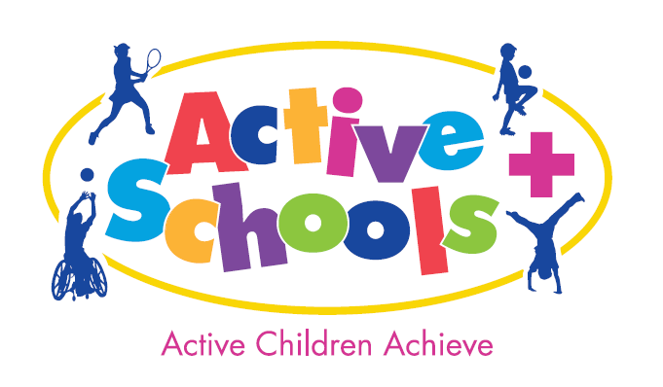

Active Schools Dance Workshop

For Staff and Y5/6 Leaders

The workshop is aimed at those wishing to develop dance within their school, no prior experience necessary.

Cost: £20 per adult, free for pupils. (Minimum of 6 to allow the course to run.)

Date | Venue | Time | Specialist
Tuesday 9th October | Leeds South: Rodillian Academy | 3.30-5.30pm | Dazl  Ian Rodley
Tuesday 23rd October | Leeds North East: Venue Immaculate Heart | 3.30-5.30pm | Freelance  Ruth Johnson
Wednesday 24th October | Leeds North West: Sacred Heart Burley | 3.30-5.30pm | Northern Arts  Sally Harrington
Thursday 6th December | Leeds East: Venue Scholes Primary. | 3.45-5.45pm | Imoves  Gail Holmes

The dance workshop is aimed at staff and Y5/6 sports leaders who are wishing to deliver extra-curricular dance clubs in their schools.

Dance is extremely popular activity choice for children and a fantastic activity for engaging your least active children. Through dance children have opportunity to be creative, express themselves, develop leadership and team work skills. Dance is also fantastic for improving mental wellbeing and increasing fitness levels. We understand from our dance audit in June that dance is often an area that staff would appreciate more support with and this course is aimed to increase your confidence facilitating a club. By engaging Y5/6 sports leaders in the deliver they can take ownership of creating the movements and with your support structure into a fun club session. During the workshop you will learn how to structure a session that will enable children to make up their own routines.

To help establish the programme in school I suggest you bring along two sports leaders who can also receive training and help with delivery.

Further to the training staff will receive teacher notes from the workshop they attended. We would also love to encourage schools to develop routines for the New Active Schools KS2 Dance Competition: Thursday 14th March at Ralph Thoresby HS.

Please find attached application form should you wish to attend. I would be most grateful if you could fax/e-mail this back no later than Friday 21st September 2018.

Assuming minimum numbers are met you will then be prompted to book and pay via Leeds for Learning.

If you require any further information, please do not hesitate to contact me.
Yours Sincerely

Natalie Mallinson
Active Schools / Leeds North West School Sport Partnership
Email: n.mallinson@stmarysmenston.org

Active Schools Dance Workshop
Name(s):…………………………… …………………………………………

School:……………………………………..

Contact No:………………………..

Medical conditions……………………………

Emergency Contact Name:……………….. ………………………..

Emergency Contact No……………………………………

Email:……………………………………

No. sports leaders………(1 or 2).

Medical conditions / learning considerations…………………………..

Date | Venue | Time | Specialist | Select
Tuesday 9th October | Leeds South: Rodillian Academy | 3.30-5.30pm | Dazl  Ian Rodley
Tuesday 23rd October | Leeds North East: Immaculate Heart | 3.30-5.30pm | Freelance  Ruth Johnson
Wednesday 24th October | Leeds North West: Sacred Heart Burley | 3.30-5.30pm | Northern Arts  Sally Harrington
Thursday 6th December | Leeds East: Venue Scholes Primary | 3.45-5.45pm | Imoves  Gail Holmes

Please return to Natalie Mallinson
St Mary’s School, Bradford Rd, Menston, Ilkley, LS29 6AE
n.mallinson@stmarysmenston.org

